8.107: a) For 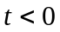 the rocket is at rest. For 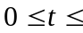 90 s, Eq. 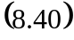 is valid, and At 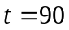s, this speed is 3.33 km/s, and this is also the speed for 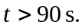

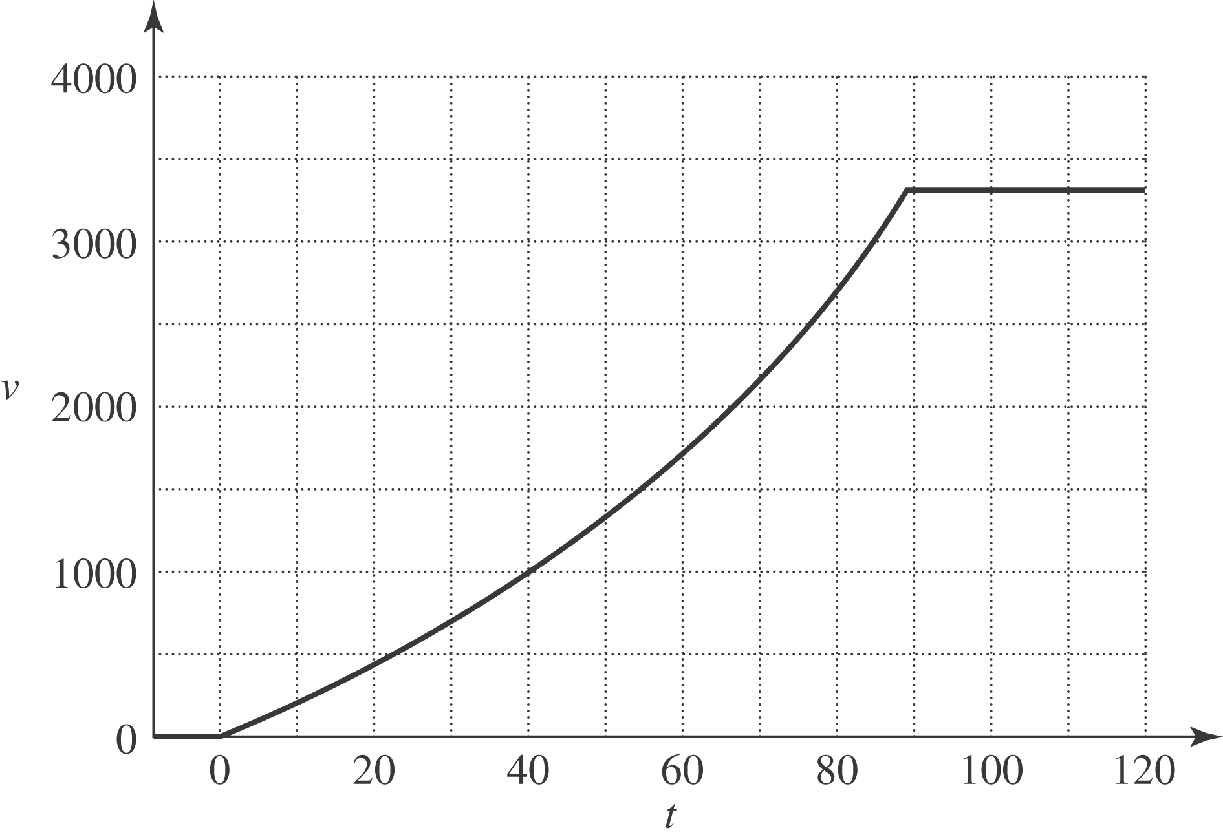

b) The acceleration is zero for 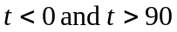 s. For 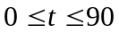 s, Eq. (8.39) gives, with 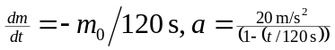.

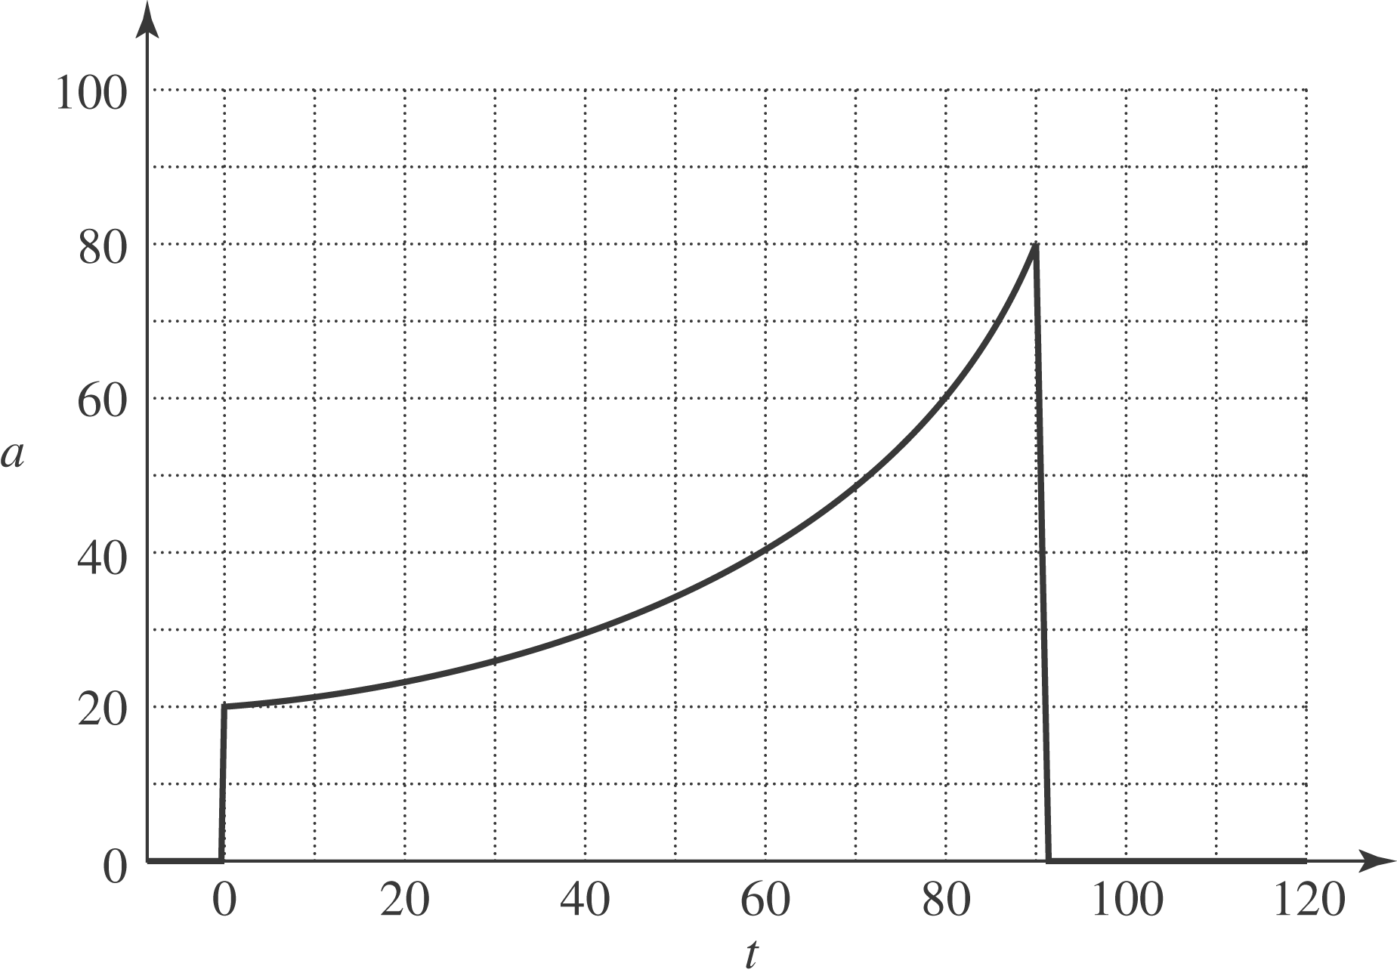
c) The maximum acceleration occurs at the latest time of firing, s, at which time the acceleration is, from the result of part (a), 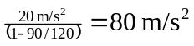, and so the astronaut is subject to a force of 6.0 kN, about eight times her weight on earth.

